CRAWFORD UNIVERSITY
HIGHLIGHTS
The Weekly Newsletter of Crawford University, Faith City, Igbesa
Http: www.crawforduniversity.edu.ng;
Our vision
To be a Centre of Excellence; producing graduates with a balanced education.

Mission
To be an International Institution of higher learning with enviable standards of teaching and research

Vol. 6 No. 005 Monday, May 16th 2022

"CUPAF IS READY TO SUPPORT THE VISION OF THE UNIVERSITY" Says Crawford Parents Forum Chairman*

Dr. Odili O. Monday (aka, Captain) is the incumbent Chairman, Crawford University Parents Forum (CUPAF). The Chairman who noted during a brief interview with the University IPPR Unit said the Parents Forum Executives is saddled with the role of projects intervention. Moreso, working towards achieving the University Vision is a collective goal.
Dr. Odili informed that he has been engaged in the helms of affairs of CUPAF as member of the Executives precisely as the first Vice Chairman between 2019 - 2021. "I later emerge as the Chairman in 2021 after the in-house election, and my tenure will elapse by 2023” he said.
A glimpse into his personal career, he reviewed that “I’m a man of double feathers, having worked as a marine in the united kingdom as a sea Man (Captain) and currently I work in a Safety and Quality Management System of the Oil and Gas Industry."
The Chairman, who further noted that CUPAF was created in 2007, fundamentally to support infrastructural development as well as to key into the university’s vision.
“Plans are ongoing for a proposed ultra modern hostel for the university, this will be a one storey building for both male and female while the female will be a 30 unit room and a 40 unit room for male respectively" said the Chairman. The Chairman also noted that the proposed hostel will also serve as a source of internal revenue for CUPAF while a profit sharing ratio of 40:60 formula will be implemented between CUPAF and the University respectively. Although, this is part of our long term goal. He said.
While inquiry was made if CUPAF had plans to increase her annual dues, the Chairman rebuffed. "No! CUPAF has no plans to increase her annual dues, instead, we shall seek for other internal revenues. However, there may not be need for the increase because CUPAF is aware there is increase in Students enrollment in the University."
The Chairman also extend his unalloyed appreciation to the University Management for not increasing her tuition fee in spite of the economy capsize.
" I feel it is not the right time to increase her tuition fees but it is necessary this will happen some time, as the increase may fall many students out of school” he said
While the IPPR Un0it inquired CUPAF contributions to beef up security on campus, considering the heights of insecurity in the country, the Chairman recounted that CUPAF has deem it fit to install the Close Circuit Cameras (CCTV) around the nooks and crannies on campus.
"CUPAF has deem it fit to install the close circuit cameras around the campus to beef up security, more so we had install an industrial bore hole water system that will salvage crises of water on campus and many other projects has been executed." Although, these are part of our short time goals, he said.
The Chairman who appreciated the University Management for her open-door policies where there is need to intervene, applaud the Management for the new security outfit on campus and also the face-lift of the University health center.

Victory at last for the EHU Contract Staff

“Weeping may endure for a night, but joy cometh in the morning” this is applicable to the Environmental and Health Unit,EHU, Contract staff as they were spurred to singing, dancing and praising God as well as giving credit & kudos to the University Authority for this feat.. These staff have been clamouring for a review of their salary structure at any opportunity they get to pour out the mind to the management staff. But their faith lamp got rekindled after the meeting the Pro-Chancellor, Prof. Modupe Asokhia had with all staff in

January, where she promised to plead the course of members of staff before the Proprietor, Rev. Isaac Adigun.
Their days of waiting ended as they received the Increment Letter today,on the 29th of April. The were however overwhelmed and flabbergasted as their joy had no bounds. According to the Increment Letter signed by the Registrar, Mr, Moses Itauma, the increment would take effect from 1st of April. The astonished and excited set of staff were however optimistic and prayed hoped for more good things for every staff of the University.

Godliness on Campus
As part of the activities to wrap up the semester, the students body of the chaplaincy has deem it fit to remember their creator in the days of their youth by holding a 1 week Revival programme, titled “FREED” (if the son therefore shall make you free, ye are free indeed John 8:36). The student Chaplain, Mr. Samuel Ogundeji, said the week was loaded with lot of variety. Signaling the start of the Revival was a film show on Sunday 9th of May. On Tuesday an outreach programme was held in the kings palace, the Onigboko of Onile-gboko, Wednesday was for Article review (Extract from Higher way Magazine). A Revival Service was held on campus for student on Thursday, then on Friday was this loaded Career & Health Seminar. The icing sugar of these revival cake was the Concert on Sunday night.

Economic Department PhD Pre-Field Defence
The journey of 3years is gradually winding up as some of the students of the Ph. D. in Economics presented their Pre-Field Defence. The programme took place in the Legacy Hall on campus for two (2) of her PhD students Mr. Kolawole Fatai Hassan and Mr. Oyeneye Olufemi Kehinde.

The HoD in his opening remarks welcomed everyone and also congratulated the student for their attainment thus far. He said that the Economics department has the highest number of P.hD student and they will maintain their position as pacesetters for all department.
The first presentation was done by Mr. Kolawole Fatai Hassan on Economics Growth and Poverty in Sub-Sahara African Countries, while the second presentation was done by Mr. Oyeneye Olufemi Kehinde on Determinant of Capital Structure: A Comparative Study of Multinational and Domestic firms in Nigeria.

Students were reminded that the presentation criticism was for value addition to their research work. Standard sets of laid down criteria were used to assess the students’ independent research work. Only those dissertation which passes through this Pre-defence can be submitted for review.

"Life Pass Book” Says NASEC
Network For African Student Entrepreneurship, NASEC, Crawford Chapter,held a seminar to mark their day for this academic Section with the theme “ Life Pass Book”. the event which took place in the Multipurpose hall had lot of these eager student entrepreneurs in attendance and some academic staff like the Dean, College of Business and Social Sciences, Prof. Amos Abisoye, Mrs Ruth Oguntuase the Ag. Director of Entrepreneurial Studies

and her assistant Mr. Ikechukwu Akazue and Mrs.Uche Nnamdi.
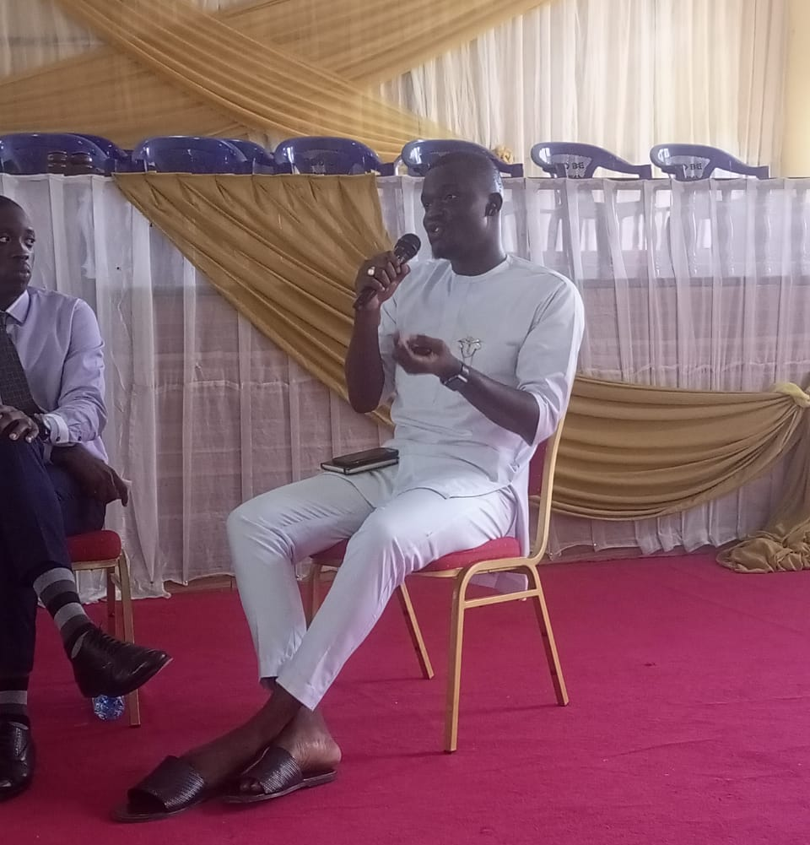
The invited speakers took their time to do justice about the theme of the day through their presentation and sharing of practical life experiences. The first speaker Mr. Akinsola Olunkunle, spoke on the things to chase and things not to chase in order to become successful, he said "Don't chase fame, or you will continually search for more fame/followers”. The second speaker Mr. Adesoji Adenugba spoke on skill acquisition, skill development and self development. The

two speakers both buttressed, that life goes far beyond academics/the educational system.There was also a chit chat session which was held by the panelists and a lot of questions were asked. The event was made more interesting by the introduction of several giveaways, and airtime, courtesy of the whole NASEC body
.

If Life were predictable it would cease to be life, and be without flavour.
…Eleanor Roosevelt

